|  |  |
| --- | --- |
| DC Plasma Lab  Comparing theoretical to observed breakdown voltages according to Paschen’s Law | Abstract  In this lab, you will synthesize the third and arguably most intriguing state of matter artificially using a high voltage source, a pump, pressure gauges and a vacuum tube. You will take multiple data readings from your setup and once we have a complete plot, we will superimpose a Paschen model and see how well the data coincides with the theoretical prediction. Along with routine data analysis and measures of central tendency, we will gauge some sort of measure of fitness to quantitatively determine how well the data coincides with the theoretical model.  Leoul Mesfin Gezu  PHYS-368: Advanced Lab II |

Table of contents

Introduction……………………………………………………………………………………………………………………………………………2

What is plasma?..............................................................................................................................2

Studying plasma…………………………………………………………………………………………………………………………3

Paschen’s Law…..…..……………………………………………………………………………………………………………………3

Pre-lab Preparation…………………………………………………………………………………………………………………………………5

Building our hypotheses…………………………………………………………………………………………………………….5

Apparatus…………………………………………………………………………………………………………………………………..6

Methods and Procedure………………………………………………………………………………………………………………………….7

Organizing data…………………………………………………………………………………………………………………………..8

Helpful tips………………………………………………………………………………………………………………………….………8

Data Analysis…………………………………………………………………………………………………………………………………………..9

Building your spreadsheet…………………………………………………………………………………………………………..9

Chi-square analysis……………………………………………………………………………………………………………………10

Results, discussion and conclusion…………………………………………………………………………………………………………11

Goal check…………………………………………………………………………………………………………………………………11

Wrapping up……………………………………………………………………………………………………………………………..11

References…………………………………………………………………………………………………………………………………………….12

INTRODUCTION

What is Plasma?

You are undoubtedly familiar with the commonly known “three states of matter”. Considering that 99% of the visible universe is actually made up of the lesser known fourth state of matter, you’d think it would be a little more widely recognized. If you’ve taken enough physics/general science, you are probably familiar with the term plasma. Answering the question “what is plasma?” actually continues the story of matter so far quite nicely. We know solids are rigid in shape and fixed in volume because their atoms are held together tightly. Liquids are held together a little less forcefully and so generally have free-formed shape, although they aren’t free enough to have unfixed volume as well. Forces between gases are so negligible that we usually assume the only interactions between them are kinetic[1] (atoms colliding). They have free-forming shape and volume that depends on their container (whether that’s your standard gas cylinder or the entire atmosphere). Now, imagine taking a gas and giving its atoms so much energy that the electrons that are bound to its nucleus have enough excitation to escape the electromagnetic force that had bound them to the nucleus. Pop off enough of them from their orbit and you can imagine a cloud of electrons occupying space the same way gas atoms do. That soup of negatively charged electrons and positively charged gas ions, that is plasma.

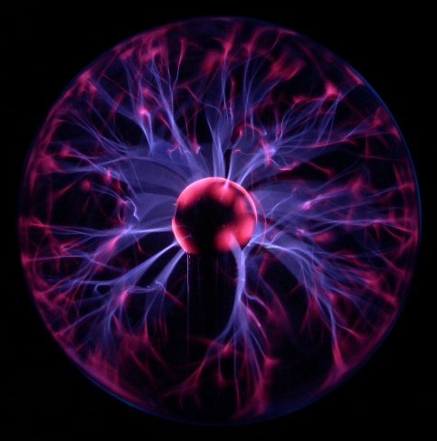

Fig. 1: Plasma Lamp[2]

Imagine its movie night and you have your favorite flavor of microwave popcorn ready to be completely finished only five minutes in. Before you put the pouch in the microwave, all you have are the hard, little corn kernels. Once they start heating up in the oven, the kernels “pop” and, eventually, you have a bag of popcorn. I think this is a solid metaphor for plasma formation. Remember, heat is a form of energy. Just like our corn kernels, transferring enough energy to our gas atoms makes their electrons “pop” off their orbits, ionizing the atom and forming the cloud we refer to as plasma.

Now, how do you know your popcorn is done? Well, the directions probably tell you how long to keep it in the microwave. Imagine we didn’t have that convenience. Imagine being inside that bag as those kernels pop (specifically the top of the bag). The first one goes off and a delicious singular popcorn flies to the top of the bag straight at you. Then, another one. The more energy is transferred to the kernels, the more popcorn flies to the top. The same way more kernels pop as it gets hotter, the more electrons pop as energy is transferred to the gas. Bringing the metaphor together, once about 90% of your kernels have popped, your popcorn is ready. Once about 90% of the atoms in a gas have ionized, we say it is fully ionized plasma.

*Talking about popcorn is all well and fun but, unfortunately, plasma is considerably more complicated than popcorn and this is about where our metaphor stops tracking. This lab is much more rewarding if you gain an appreciation for what plasma really is. And so, if you feel like you need a little bit more background on plasma and its properties, I urge you to stop and watch this great video*[3] *and any other resources you can find before we build more complexity into our understanding.*

Studying plasma

If we as physicists are to study plasma formation, we have two choices. We can wait for nature to create them (as it does all the time in the form of lightning strikes and solar winds). That would be very inconvenient, unpredictable and mildly dangerous. Thankfully, we have methods for artificially forming plasma in the lab, the most inexpensive and methodically straight-forward of which is the use of parallel plates and a high voltage source. Remember, all we need to do is somehow transfer enough energy to the gas atoms that their electrons ionize and we form plasma. If we keep this plasma somehow enclosed, we can observe its formation and even keep track of certain important numbers (the pressure in the tube, the distance between the plates and the voltage we needed to hit to see our first formation of plasma).

Part of being a physicist is understanding that you do not need to rediscover the electron in order to execute a successful experiment. In reality, the relationships between those numbers I just mentioned are very well documented, confirmed and understood. This very same lab has been repeated by thousands of students across multiple academic institutions across multiple continents. By no means should this be discouraging. Peer review is the bread and butter of the research. The fact that you can repeat this lab, executing it the same way it has been done in previous iterations and potentially get comparable results is the very fabric of the scientific method. In the future, you may perform an original experiment of your own that gets peer-reviewed by thousands of scholars to come. But, for now, let’s learn what our predecessors have found and form a hypothesis to test for ourselves.

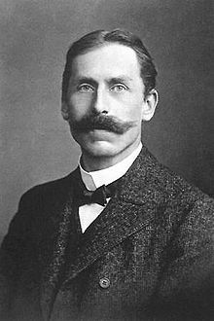Paschen’s Law

The German physicist with the phenomenal mustache you see to the right was Friedrich Paschen. One of his most important contributions to the world of physics was the relationship between the voltage that is necessary to start a discharges/electric arc between two electrodes as a function of surrounding pressure and the gap length between the electrodes. An electric arc is indeed plasma, so we’re talking about plasma formation here. This relationship is now dubbed Paschen’s Law and is the cornerstone of this entire lab activity. Before Paschen’s Law empirically states it for us, let’s conceptually think about what the relationships between breakdown voltage, pressure and separation distance could be.

Fig. 2: Friedrich Paschen

Imagine we had a constant separation distance (we’re changing just the pressure and seeing how the breakdown voltage is affected). Thinking about how pressure affects a gas, more pressure bearing down on our gas atoms would likely mean it is harder for the anything (atoms or electrons or corn kernels) to move freely and ionize. Therefore, we would expect more energy to be required and therefore a higher breakdown voltage necessary as pressure increases.

Now, we also know that the voltage between two electrodes is directly proportional to the distance between them[4]. Imagining that the pressure was constant and we’re just changing the separation distance, we would expect that a shorter distance between the electrodes would require less voltage.

Despite these reasonable expectations, real-life measurements find that while the voltage necessary decreased as pressure was decreased, it eventually increases gradually and even exceeds the original value. Similarly, the voltage necessary decreased as the separation distance decreased, but only to a certain point. It also then exceeds its original value. This is indeed very surprising, and was the dilemma that Paschen and colleagues set out to sort. Paschen experimentally discovered the relationship between these three values and it is empirically stated in Paschen’s Law:

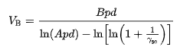

Fig. 3: Paschen’s Law[5]

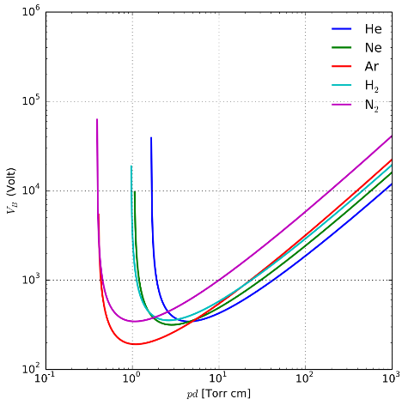

In this equation, VB stands for breakdown voltage and pd stands for pressure times distance (not potential difference!). This is key. Plotting Paschen’s Law leads to a Paschen curve with breakdown voltage on the dependent axis and the product of pressure and separation distance on the independent axis. This is unusual if you are used to seeing only one variable on a single axis, but don’t worry. Everything you know about axes still applies; you just have this new pressure-distance variable on your x-axis and breakdown voltage on your y-axis. The rest of the quantities in this equation are A and B, which are experimentally found constants that are usually in a certain range for a given gas, and the γ, which is also a constant known as the secondary electron emission coefficient. It is also given for a certain gas.

Figure 4: Paschen curves for different gases

And with that, you have all the background knowledge you need to execute and more importantly enjoy this lab. This is the step in the process where you look back and make sure all the concepts from the definition of plasma to the unusual x-axis in our Paschen curve make sense. Don’t be afraid to look back and/or consult other resources if anything feels too daunting. Proceed to the next section when you are ready!

Pre-lab Preparation

Building our hypotheses

Given all we’ve covered so far, you may already see the picture of our experiment starting to form. We have, at our disposal, a high voltage DC power supply, a vacuum tube fitted with a pressure gauge and an evacuation pump. We have a model that potentially predicts the values we observe from apparatus. Let’s see how accurately we can recreate the results of the theoretical Paschen model within a reasonable quantitative measure of fitness value (below 10%):

* The observed breakdown voltages and the theoretical values will coincide within a fitness parameter below 10%

Now, like we mentioned earlier, our constants A and B are estimates (experimentally found constants) that lie within a certain range. It would be useful if we could determine some sort of error in those constants and compare them to the usual ranges. Therein, our second hypothesis could be:

* The error we extract from our constants will be roughly in line with the accepted range of values for the parameters

Feel free to hypothesize further and think about the implications of our experiment. For the sake of brevity, let us condense our goals for the lab so far:

* Obtain a measure of fitness between observed breakdown voltages and the theoretical Paschen model
* Determine error in the relevant constants depending on resulting fit

We are now ready to set up our apparatus and get ready to take some data. Although I have urged you to take your own path up to this point, this is the part where you need to follow the instructions precisely. We are working with lethally high voltages being applied to glass chambers with significant pressure being applied to them. There’s risk of implosions, explosions and electrocutions on top of the usual mishaps of a lab activity. Here are some general guidelines below. Once you’re ready, move on to the practical aspects of this lab.

* DON’T touch any metal parts while you are conducting a reading
* DO exhibit caution while turning up the voltage and pressure
* DON’T turn the vacuum pump on or off without performing the steps outlined later
* DO turn the voltage to zero before making any adjustments
* DO take a picture of the plasma once it forms and tell your non-physics friends that you’re building a lightsaber 😊

Apparatus

Although we’ve mentioned them here and there, here’s an exhaustive list of all the apparatus involved in this experiment and pictures of them so you can readily identify what is what:

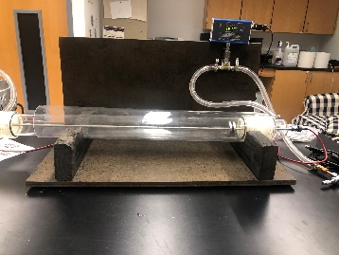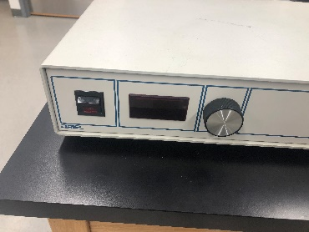

Figure 6: Vacuum Tube

Figure 5: High Voltage DC Power Supply

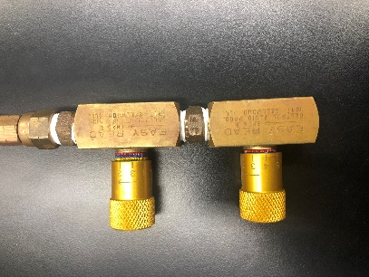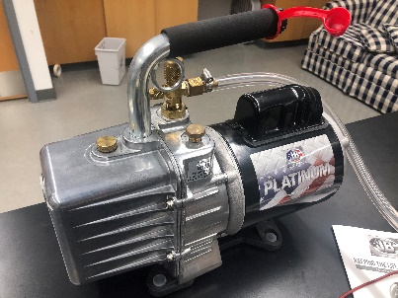

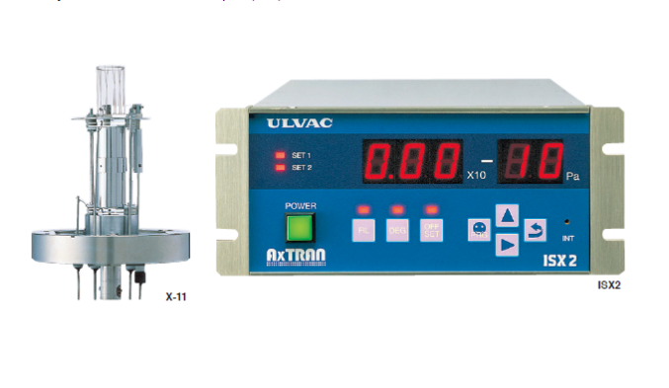

Figure 9: Pressure Monitor

Figure 8: Pressure Gauges

Figure 7: Evacuation pump

Your assembled experimental setup should look like this:

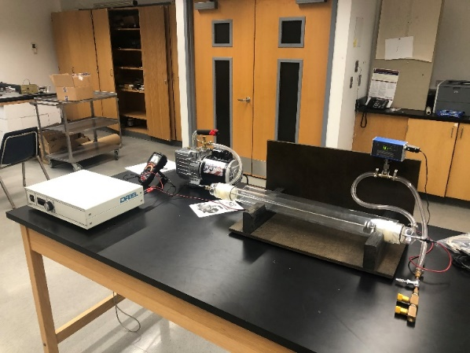

Figure 10: Assembled setup

The plasma will form in the vacuum tube. The pressure inside of the tube is maintained by the air continually being evacuated by the pump. You can maintain the pressure by turning the dials on the pressure gauges. The digital pressure reader should give you a real-time estimate of the pressure. You can change the distance between the electrodes by pulling the metal rod on the left side of the vacuum tube (only grab the insulated sections with your hands). Once you have achieved a stable pressure and a desired separation distance, you can turn on the voltage source and increase the reading slowly until you see plasma form between the electrodes. This is the overall procedure; you are now prepared to follow the detailed instructions in the next section.

Methods and Procedure

**Step 1: Starting the pump (see figure 7)**

1. Make sure the pressure gauges aren’t fully closed before starting the pump (this might damage the needles inside)
2. Make sure the pump is plugged in.
3. Before starting the pump, open the isolation valve (turn the plastic switch up on the side of the pump) and make sure the gas ballast (the metal knob next to the isolation valve) is closed.
4. Start the pump and immediately crack open the gas ballast. After the pump quiets down from the initial evacuation, close the gas ballast.

**Step 2: Setting separation distance (see figure 6)**

1. This is the easier of the steps outlined. Just pull or push the metal rod to the right of the vacuum tube. The distance between the insulating rubber ends corresponds to the distance between the electrodes, so you don’t need to try to look through the glass to determine the distance between the electrodes.
2. Once you have achieved your desired separation distance, move on to regulating pressure

**Step 3: Regulating pressure (see figure 8 and 9)**

1. By this point, you should see the pressure readout slowly approaching a value. Wait for it to level out
2. There are three dials on the pressure gauge. The one on top is the fine adjustment. The bottom two are coarse adjustments. Turn the coarse knobs until you are within 50-100 mTorr of your desired pressure, then turn the fine knob to get as close as possible to your desired value.
3. Do not expect to perfectly achieve your desired pressure. This will be incredibly difficult to achieve. Aim for a 1-20 mTorr range.
4. Once you have achieved a value inside your desired range, note that pressure move on.

**Step 4: Applying voltage and noting breakdown of plasma (see figure 5)**

1. Make sure the voltage source is plugged in and you aren’t directly touching any metal connections. Slowly turn up the dial (increments of 5 volts at a time are more than sufficient). Make sure you’re ready to note the value as soon as you see plasma breakdown.
2. The voltage right when you start to see the purple glow between the electrodes is your breakdown voltage.
3. Once you have your value, slowly turn it down all the way to zero before you do anything else.

Organizing data

You know now how to extract data from this setup. Use a table to keep things organized. We’re going to need a lot more than one data point to form a recognizable Paschen curve, so use a table like the following to repeat the steps outlined above and get more data points.

|  |  |  |
| --- | --- | --- |
| Pressure (mTorr) | Separation Distance (cm) | Breakdown Voltage |
| x | y | z |
| …. | …. | …. |
| …. | …. | …. |

Helpful tips:

* Have one member of your team actively import the data into an Excel sheet (especially when you’ve already taken a lot of data points). Once you start to see a figure forming, it will be apparent what ranges your plot is missing. For example: if you see a large gap in the 4000-5000 range on the x-axis, you’ll know to try, for example, to get the pressure up to 400-500 mTorr at a separation distance of 10 cm (because 400*10 = 4000).
* The reading on the voltage source can jump down to a much lower value right when the plasma breaks down. Make sure you’re getting the value before the jump. This might skew your data.

Here’s an example of a filled-out plot. Aim for something like this and proceed to the analysis when you are satisfied.

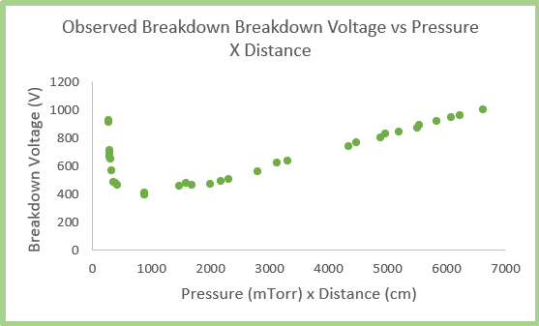

Figure 11: Example of observed plot

Data Analysis

Building your spreadsheet

If you have made it to this point, take a moment to pat yourself on the back. You’re done with the practical aspect of this lab. Now, it’s time to see how well the data you took aligns with the theoretical prediction. Speaking of, how about we see what this theoretical prediction we keep mentioning actually is?

You should already have been doing this, but start off by importing all the data into a spreadsheet. Right next to our recorded breakdown voltages, create a column and call it theoretical model. Now, we know that Paschen’s Law determines the breakdown voltage according to the equation below, which also depends on the constants A, B and γ. Make a separate section on your spreadsheet to note these values. You can find the publications where we got these values cited in the footnote if you’d like. Don’t forget to make sure your units are consistent with the units of the constants.

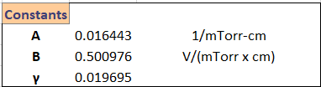

Figure 14: Table of constants

Figure 1: Paschen’s Law

Input Paschen’s Law as an equation into the first cell of your theoretical column, using the relevant cells for each value (variables and constants). Be careful with your parenthetical notation in the equation and make sure your using Excel’s $ notation for the constants so they don’t change when you drag the cell down to fill the rest of the cells.

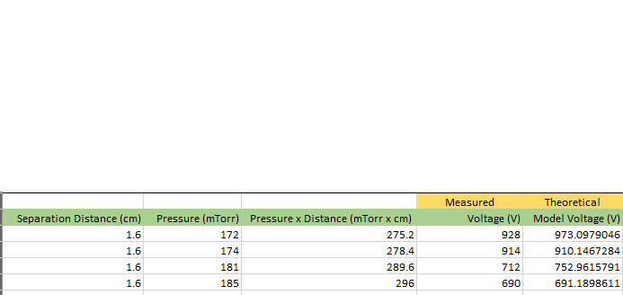

Figure 15: Example of spreadsheet structure

You now have a series that represents your theoretical model. Let’s plot it as a line graph and see how well it coincides with the observed series. You should see something like this:

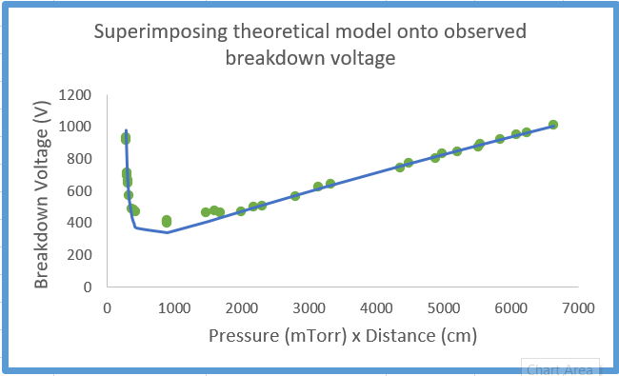

Figure 16: Example of observed-theoretical overlay

Chi-square analysis

From the preliminary plots we made above, you should be getting a feeling for how well your data matches the theoretical model. As an exercise, pick which qualifier best describes your data:

1. Really well
2. Pretty well
3. Kind of
4. Not really
5. Are we doing the right experiment?

Got your answer? Good. Hope you got that out of your system because describing data like this in a lab report is one of the seven deadly sins of science. You’ll notice how each one of your team members and even your professor would probably choose a different answer to that question. The only real way to objectively gauge how well the data aligns with the theoretical model is to perform some sort of quantitative analysis. For this experiment, we will be using a chi-square analysis and its fitness parameter in order to obtain a quantitative measure of fitness.

If you are a little rusty on your statistics or if you haven’t taken a statistics class at all, this is the time to pause and revise. The resource in the footnote[6] is an excellent start. Feel free to consult any other websites, videos and/or text books.

Follow the steps below to perform your chi-square analysis:

1. 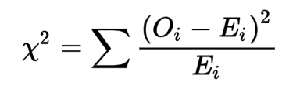The picture to the left is the formula for the chi-square value. Oi stands for observed value (observed breakdown voltage), Ei stands for expected (theoretical breakdown voltage).
2. As the summation notation indicates, once you have a value for each observed-theoretical pair, sum them all up. That is your chi-square value.

Figure 17: Chi-square formula

1. Determine your reduced chi-square by dividing your chi-square by the number of data points
2. Determine your degrees of freedom by thinking about your independent variables (pressure and distance in our case, so two)
3. Determine your fitness parameter by using the Excel function: CHISQ.DIST.RT(reduced chi-square, degrees of freedom)

Condensing all those steps on a section of your spreadsheet, you should have something resembling the following:

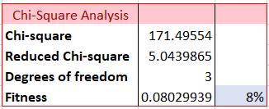

Figure 18: Example of chi-square analysis

Results, discussion and conclusion

Goal check

This is a great time to reflect on our initial goals:

* Obtain a measure of fitness between observed breakdown voltages and the theoretical Paschen model DONE
* Determine error in the relevant constants depending on resulting fit PENDING

Determine error in the relevant constants

In order to determine an error in the relevant constant, we must first identify the relevant constant. This is going to depend on your own plot. Try to visually identify where in your plot it is that your data points are most skewed from the theoretical prediction.

* If it is in the curvy head of the Paschen curve, your relevant constant is A since it is the one in the logarithmic function (look at Paschen’s Law equation)
* If its in the long tail of the Paschen curve, your relevant constant is B since it is the one function-free in the numerator (again, look at Paschen’s Law equation)

This is where a little trial and error comes into play. First, note your original value for the relevant constant. Then, try changing your relevant constant in small increments in the second decimal place until the data points are better aligned. Once the divergence seems resolved, note the new value for your relevant constant.

Subtracting those values should give you an estimate for the error in the constant.

Wrapping up

Once you have completed your experiment by all accounts, it’s time to think about what we can really say about the results. Obviously, this is case-sensitive and will depend on your own results, but the general theme is thinking about how you can show your reader the significance of your results with a detailed account of what happened in the experiment. Here are some guiding questions to ask yourself:

* What are the theoretical implications of our results?
* Are all the premises that lead to my conclusion clear?
* What can we do better to improve the results of this experiment?



You are officially done with the DC Plasma lab! Like you should with all academic endeavors, reflect on your journey, retain the good and think about how to rectify the not-so-good for the future.

References

Taylor, J. R. (1997). An Introduction to Error Analysis: The Study of Uncertainties in Physical

Measurements. Mill Valley, CA: University Sciences.

1. See Kinetic Theory of Gases if you would like to learn more about how we treat gases for thermodynamic considerations: https://en.wikipedia.org/wiki/Kinetic_theory_of_gases
2. https://en.wikipedia.org/wiki/File:Plasma-lamp_2.jpg
3. https://www.youtube.com/watch?v=zqzWfguYj1c
4. See “parallel plate voltage” or the following resource if you need a little revision on this: https://flexbooks.ck12.org/cbook/ck-12-physics-flexbook-2.0/section/16.1/primary/lesson/the-electric-potential-in-a-uniform-field-phys
5. https://en.wikipedia.org/wiki/Paschen%27s_law
6. https://brilliant.org/courses/statistics/